

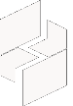

MICROSOFT ARCHITECTURE BEST PRACTICE FOR CLOUD AI PLATFORM
USECASE: GREENFIELD LAKEHOUSE ON MICROSOFT FABRIC

Document Title | Microsoft Cloud Center of Excellence Overview
Presales/Technical Head | Tushar Mehrotra/Rohit Pandey
CCoE Lead | Ravishankar N
Creation Date | December 2025
Version | Description | Modified by | Date | Approved by | Date
1 | Initial Architecture design | Ranu Kumar | 15/12/2025 | Ravi Shankar | 15/12/2025
2 | Operational Management | Ranu Kumar | 15/02/2026 | Ravi Shankar | 15/02/2026
3 | Reusability and Extensibility | Ranu Kumar | 29/04/2026 | Ravi Shankar | 29/04/2026
Contents
1
1. Executive Summary 3
2. Scope and Applicability 3
3. Business Scenario Overview 3
4. Reference Architecture Overview 4
4.1 Architecture Description 4
5. Logical Architecture Components 4
5.1 Data Sources 4
5.2 Ingestion Layer 5
5.3 Storage Layer – OneLake (Lakehouse) 5
5.3 Semantic and Consumption Layer 5
6. Architectural Best Practices 6
6.1 Lakehouse Design and Data Organization 6
6.2 Performance and Cost Management 6
6.3 Operational Management 6
7. Reusability and Extensibility ……………………………………………………………………………………………..7
8. Conclusion 7

Greenfield Lakehouse on Microsoft Fabric

Executive Summary
This document describes a standardized reference architecture and associated best practices for implementing a modern data and analytics platform using Microsoft Fabric. The architecture is curated and maintained by the organization’s Cloud Center of Excellence to support consistent solution design, delivery quality, and operational robustness across customer engagements.
The content is intended for use by solution architects, delivery teams, and partner engineering teams, and reflects established Microsoft-recommended design patterns for lakehouse-based analytics platforms.

Scope and Applicability
This reference architecture applies to:
- Analytics and reporting solutions built on Microsoft Fabric
- Data modernization and lakehouse initiatives
- Batch and near real-time analytics workloads
- Structured and semi-structured enterprise data sources
- Small, mid-market, and enterprise customer environments
The architecture is designed to be deployable across multiple geographies while adhering to regional compliance, data residency, and governance requirements.

Business Scenario Overview
Organizations increasingly require a unified analytics platform that can ingest data from multiple sources, process it efficiently, and make insights available to business users with minimal latency and duplication. Traditional data warehouse-centric models often introduce complexity, data silos, and operational overhead.
A lakehouse-based approach using Microsoft Fabric enables:
- Centralized storage of enterprise data in open formats
- Simplified analytics across SQL, Spark, and BI workloads
- Reduced data movement through a single, integrated platform
- Readiness for advanced analytics and AI-driven insights

Reference Architecture Overview

4.1 Architecture Description
The architecture is based on a greenfield lakehouse design implemented using Microsoft Fabric. It leverages OneLake as the unified data foundation and integrates data ingestion, transformation, analytics, and visualization within a single managed platform.
High-Level Architecture Description
- Source systems feed data into Fabric through managed ingestion services
- Data is stored in OneLake using a zone-based lakehouse pattern
- Transformations are performed using Spark and SQL experiences
- Curated data is exposed through semantic models for reporting and analysis
- Advanced analytics and AI workloads consume the same governed datasets
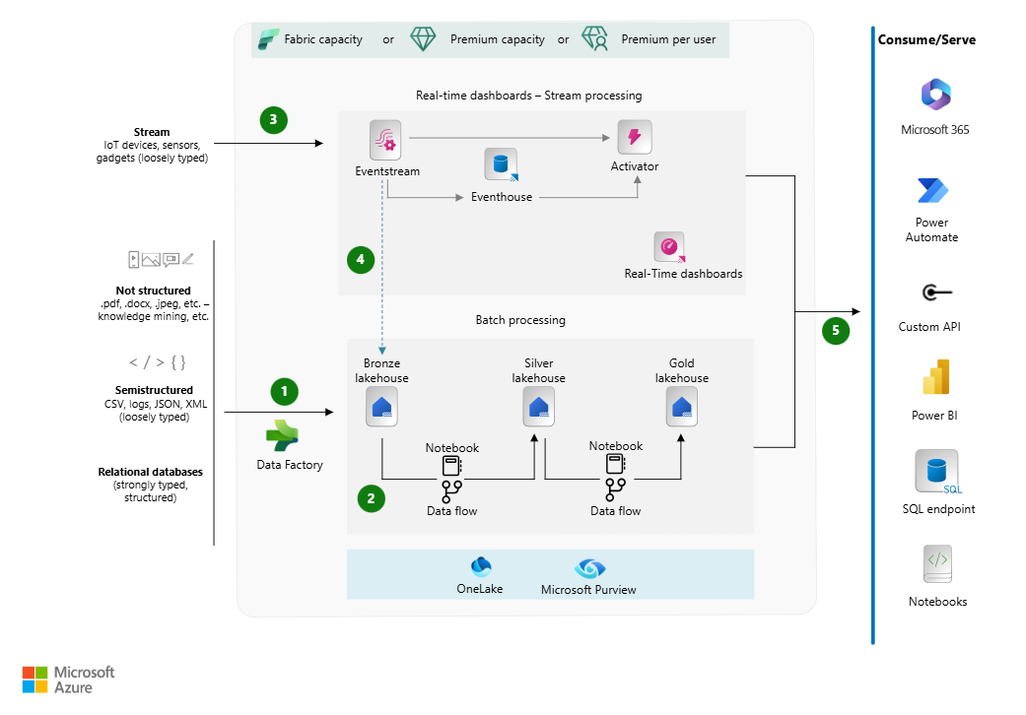

Logical Architecture Components

5.1 Data Sources
Enterprise data originates from multiple systems, including:
- Line-of-business applications (ERP, CRM)
- Operational databases
- File-based data sources
- Event and streaming platforms
These sources provide structured and semi-structured data for ingestion into the platform.

Ingestion Layer
Data ingestion is implemented using Microsoft Fabric data pipelines and event-based ingestion capabilities. Key characteristics include:
- Native connectors to common enterprise systems
- Support for batch and streaming ingestion patterns
- Orchestration, scheduling, and dependency management
- Built-in retry and error handling mechanisms

5.3 Storage Layer – OneLake (Lakehouse)
OneLake serves as the unified storage layer for all analytics workloads. Data is organized using a tiered lakehouse approach:
- Raw Zone: Ingested data stored in its original format
- Refined Zone: Cleansed and standardized datasets
- Curated Zone: Business-ready data optimized for consumption
Data is stored in open formats such as Delta Lake to ensure interoperability and long-term flexibility.
Processing and Analytics Layer
Data processing and analytics are performed using:
- Spark-based data engineering workloads for large-scale transformations
- SQL analytics endpoints for relational querying and integration
- Shared execution engines that operate directly on OneLake data
This approach eliminates unnecessary data duplication while supporting multiple analytics styles.

Semantic and Consumption Layer
Curated datasets are exposed to business users through:
- Power BI semantic models
- Interactive dashboards and reports
- Secure data sharing across teams and domains
Where applicable, Direct Lake access is used to enable high-performance analytics without data import overhead.
Advanced Analytics and AI
The architecture supports advanced analytics scenarios, including:
- Exploratory data analysis using notebooks
- Machine learning model development
- Integration with AI-assisted analytics and Copilot capabilities
All advanced workloads operate on governed datasets within the same platform.

Security and Governance Considerations
Security and governance are implemented as foundational design principles:
- Authentication and authorization via Microsoft Entra ID
- Role-based access control at workspace and data levels
- Encryption of data at rest and in transit
- Data classification and sensitivity labeling
- Centralized administrative controls for platform governance
These controls ensure secure access while enabling controlled self-service analytics.

Architectural Best Practices

6.1 Lakehouse Design and Data Organization
- Separate workloads by functional domain where appropriate
- Maintain distinct environments for development, testing, and production
- Apply standardized naming and access conventions

6.2 Performance and Cost Management
- Prefer Direct Lake access for analytical workloads
- Monitor capacity utilization and query performance
- Scale resources based on consumption patterns

6.3 Operational Management
- Implement monitoring and alerting for pipelines and workloads
- Maintain operational documentation and runbooks
- Regularly review and optimize data models and transformations
Azure AI Search skillsets support Microsoft Responsible AI principles through controlled AI enrichment workflows
- Reusability and Extensibility
This reference architecture is designed to be reused across multiple engagements and extended to support additional use cases, including:
- Departmental analytics platforms
- Enterprise data modernization programs
- AI and machine learning initiatives
The modular design allows teams to adopt components incrementally while preserving overall architectural consistency.

Conclusion
The Microsoft Fabric lakehouse reference architecture described in this document provides a robust, scalable, and governed foundation for modern analytics solutions. By standardizing on proven architectural patterns and best practices, the organization ensures consistent delivery quality, operational efficiency, and long-term platform sustainability across customer and partner environments.

